1. Write a program that finds the largest number in an array of 5 numbers

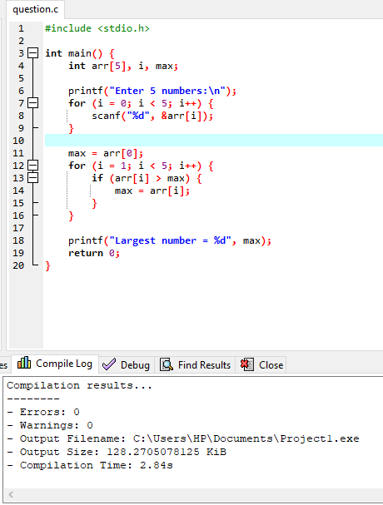

Output

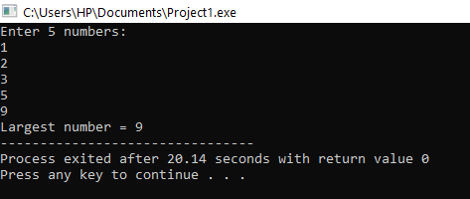

1. Write a program that swipe two numbers using pointers

Source code

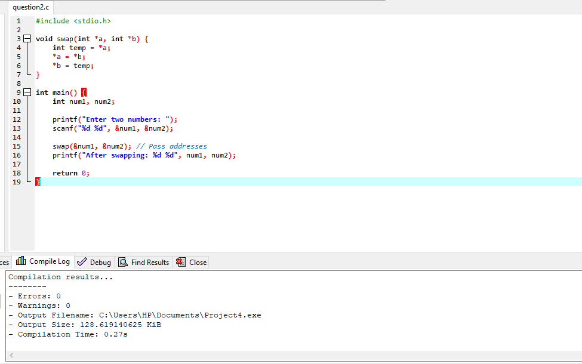

Output

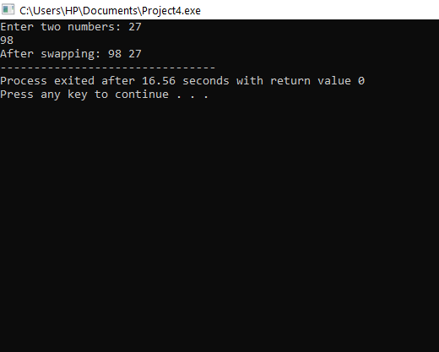

1. Write a program that stores and display students details using structures

### ****Source code****

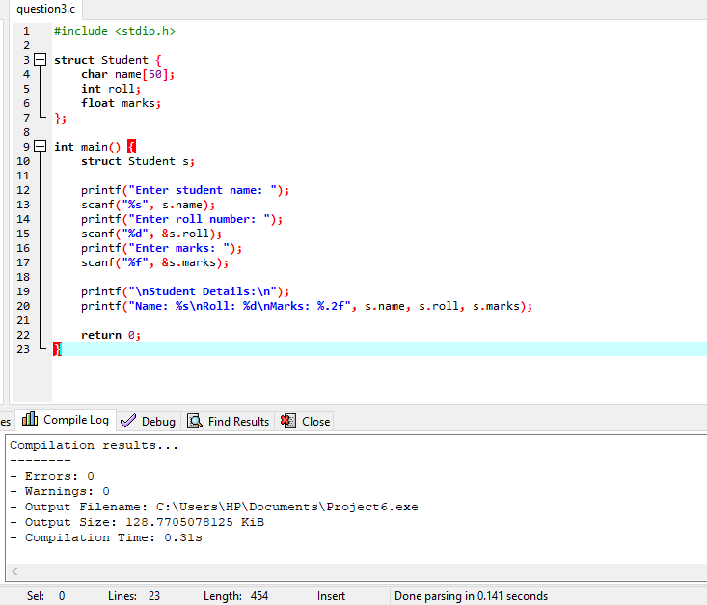

Output

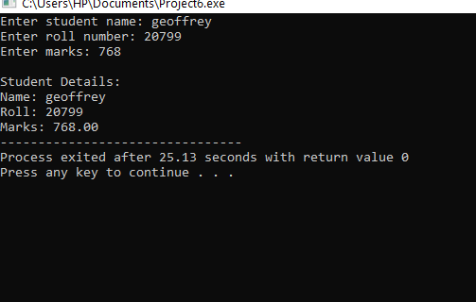

**4.** Write a program that checks if a given number is prime

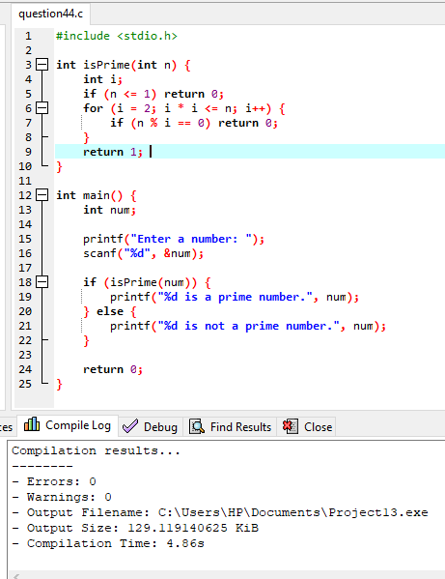

Output

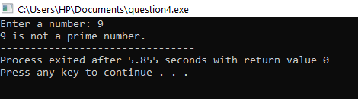

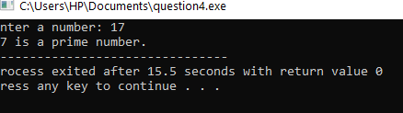

**5.** Write a program that sorts an array of integers using the bubble-sort algorithm

### 

Output

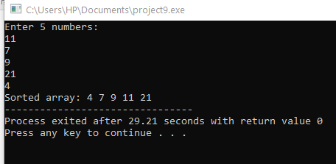

1. Create a simple C program that allows two players to play tic-tac-toe

### 

### 

Output

